DLD Software lab #1

Mohammad Yehya Hayati, 21K-3309, BCS-2G

Table of Contents

**Task #1** 2

**Task #2** 3

**Task #3** 4

**Task #4** 5

Part #1 5

Part #2 6

Part #3 7

Part #4 8

Part #5 9

Part #6 10

Part #7 11

# **Task #1**

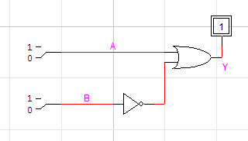

|  |  |  |
| --- | --- | --- |
| **INPUT(A)** | **INPUT(B)** | **OUTPUT** |
| 0 | 0 | 1 |
| 0 | 1 | 0 |
| 1 | 0 | 1 |
| 1 | 1 | 1 |

# **Task #2**

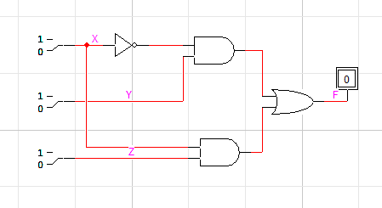

|  |  |  |  |
| --- | --- | --- | --- |
| **INPUT(X)** | **INPUT(Y)** | **INPUT(Z)** | **OUTPUT(F)** |
| 0 | 0 | 0 | 0 |
| 0 | 0 | 1 | 0 |
| 0 | 1 | 0 | 1 |
| 0 | 1 | 1 | 1 |
| 1 | 0 | 0 | 0 |
| 1 | 0 | 1 | 1 |
| 1 | 1 | 0 | 0 |
| 1 | 1 | 1 | 1 |

# **Task #3**

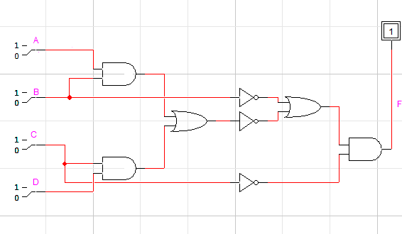

|  |  |  |  |  |
| --- | --- | --- | --- | --- |
| **INPUT(A)** | **INPUT(B)** | **INPUT(C)** | **INPUT(D)** | **OUTPUT(F)** |
| 0 | 0 | 0 | 0 | 1 |
| 0 | 0 | 0 | 1 | 1 |
| 0 | 0 | 1 | 0 | 0 |
| 0 | 0 | 1 | 1 | 0 |
| 0 | 1 | 0 | 0 | 1 |
| 0 | 1 | 0 | 1 | 0 |
| 0 | 1 | 1 | 0 | 0 |
| 0 | 1 | 1 | 1 | 0 |
| 1 | 0 | 0 | 0 | 1 |
| 1 | 0 | 0 | 1 | 1 |
| 1 | 0 | 1 | 0 | 0 |
| 1 | 0 | 1 | 1 | 0 |
| 1 | 1 | 0 | 0 | 0 |
| 1 | 1 | 0 | 1 | 0 |
| 1 | 1 | 1 | 0 | 0 |
| 1 | 1 | 1 | 1 | 0 |

# **Task #4**

## Part #1

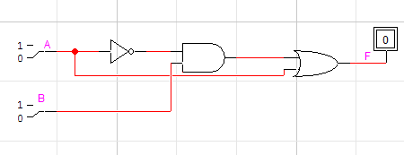

|  |  |  |
| --- | --- | --- |
| **INPUT(A)** | **INPUT(B)** | **OUTPUT(F)** |
| 0 | 0 | 0 |
| 0 | 1 | 1 |
| 1 | 0 | 1 |
| 1 | 1 | 1 |

## Part #2

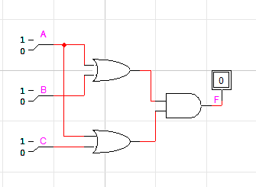

|  |  |  |  |
| --- | --- | --- | --- |
| **INPUT(A)** | **INPUT(B)** | **INPUT(C)** | **OUTPUT(F)** |
| 0 | 0 | 0 | 0 |
| 0 | 0 | 1 | 0 |
| 0 | 1 | 0 | 0 |
| 0 | 1 | 1 | 1 |
| 1 | 0 | 0 | 1 |
| 1 | 0 | 1 | 1 |
| 1 | 1 | 0 | 1 |
| 1 | 1 | 1 | 1 |

## Part #3

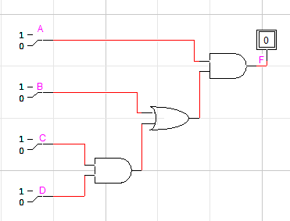

|  |  |  |  |  |
| --- | --- | --- | --- | --- |
| **INPUT(A)** | **INPUT(B)** | **INPUT(C)** | **INPUT(D)** | **OUTPUT(F)** |
| 0 | 0 | 0 | 0 | 0 |
| 0 | 0 | 0 | 1 | 0 |
| 0 | 0 | 1 | 0 | 0 |
| 0 | 0 | 1 | 1 | 0 |
| 0 | 1 | 0 | 0 | 0 |
| 0 | 1 | 0 | 1 | 0 |
| 0 | 1 | 1 | 0 | 0 |
| 0 | 1 | 1 | 1 | 0 |
| 1 | 0 | 0 | 0 | 0 |
| 1 | 0 | 0 | 1 | 0 |
| 1 | 0 | 1 | 0 | 0 |
| 1 | 0 | 1 | 1 | 1 |
| 1 | 1 | 0 | 0 | 1 |
| 1 | 1 | 0 | 1 | 1 |
| 1 | 1 | 1 | 0 | 1 |
| 1 | 1 | 1 | 1 | 1 |

## Part #4

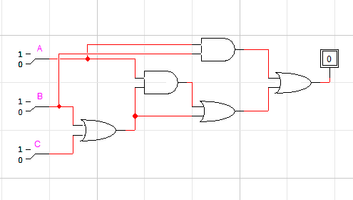

|  |  |  |  |
| --- | --- | --- | --- |
| **INPUT(A)** | **INPUT(B)** | **INPUT(C)** | **OUTPUT(F)** |
| 0 | 0 | 0 | 0 |
| 0 | 0 | 1 | 1 |
| 0 | 1 | 0 | 1 |
| 0 | 1 | 1 | 1 |
| 1 | 0 | 0 | 0 |
| 1 | 0 | 1 | 1 |
| 1 | 1 | 0 | 1 |
| 1 | 1 | 1 | 1 |

## Part #5

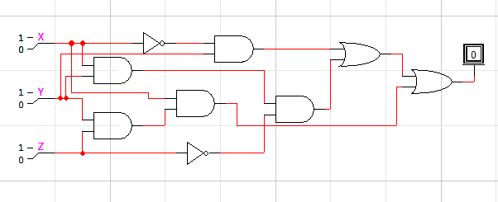

|  |  |  |  |
| --- | --- | --- | --- |
| **INPUT(X)** | **INPUT(Y)** | **INPUT(Z)** | **OUTPUT(F)** |
| 0 | 0 | 0 | 0 |
| 0 | 0 | 1 | 0 |
| 0 | 1 | 0 | 1 |
| 0 | 1 | 1 | 1 |
| 1 | 0 | 0 | 0 |
| 1 | 0 | 1 | 0 |
| 1 | 1 | 0 | 1 |
| 1 | 1 | 1 | 1 |

## Part #6

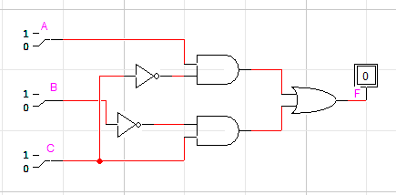

|  |  |  |  |
| --- | --- | --- | --- |
| **INPUT(A)** | **INPUT(B)** | **INPUT(C)** | **OUTPUT(F)** |
| 0 | 0 | 0 | 0 |
| 0 | 0 | 1 | 1 |
| 0 | 1 | 0 | 0 |
| 0 | 1 | 1 | 0 |
| 1 | 0 | 0 | 1 |
| 1 | 0 | 1 | 1 |
| 1 | 1 | 0 | 1 |
| 1 | 1 | 1 | 0 |

## Part #7

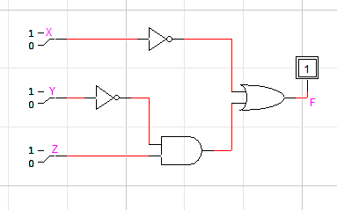

|  |  |  |  |
| --- | --- | --- | --- |
| **INPUT(X)** | **INPUT(Y)** | **INPUT(Z)** | **OUTPUT(F)** |
| 0 | 0 | 0 | 1 |
| 0 | 0 | 1 | 1 |
| 0 | 1 | 0 | 1 |
| 0 | 1 | 1 | 1 |
| 1 | 0 | 0 | 0 |
| 1 | 0 | 1 | 1 |
| 1 | 1 | 0 | 0 |
| 1 | 1 | 1 | 0 |